Manor Park Nursery Newsletter
Summer term 2 2023
Welcome back!
We are so excited to start another very busy half-term with the children. Here is a brief overview of what is in store in the coming weeks……….
This half term we will be looking at:
Change of season – Summer
Minibeasts
At the Seaside
Transition to Reception

Take Home
- Library books
- Take home teddy and diary
- ‘Our magic moment vouchers
- Home-school links

Sports Day – Wednesday 7th June at 2pm Everyone Invited!!
Big 5 Books
Little Turtle and the song of the sea
Sally and the Limpet
Bee and Me
The boy who lost his bumble

Rhymes
Tiny Tim
The Ocean Song
The Pirate Song
Here is the bee hive where are the bees?
If you’re happy and you know it!

We continue to ask for a voluntary 50p contribution per week to help provide the children with additional baking or special activities throughout the year – This half term has a sunny theme!
Practise at home
Getting dressed
Putting on socks and shoes

Classroom essentials to be left at Nursery:

Named indoor shoes that the children can manage themselves – Crocs are ideal

A named bag with a change of clothing

Vocabulary
Ladybird
Wings
Legs
Bees
Honey
Nectar
Pollen

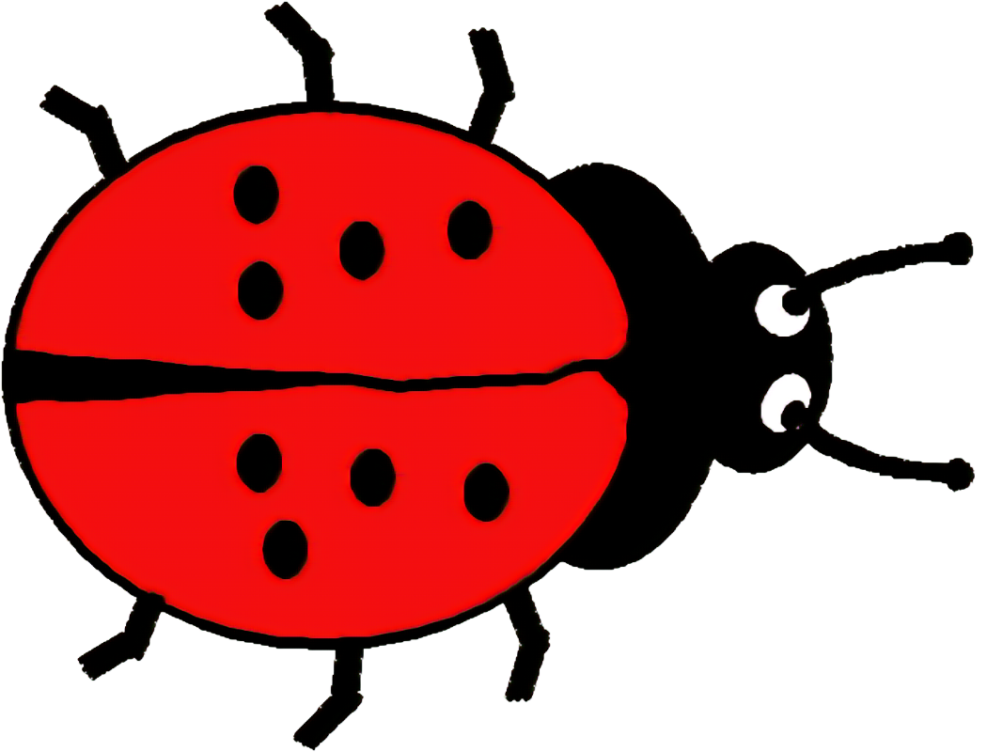
Essentials to bring every day

A coat and sun hat
Please ensure your child is wearing sun cream before they come to Nursery!

A healthy lunch (if staying for lunch)


