

Look what I can do
before I start in
Nursery

Name:

Parents / Carers,

Welcome to Manor Park Nursery, we hope you and your child will be very happy here.

We want all our children to have the best opportunity to develop and realise their full potential. A way of making this possible is for home and Nursery to work together.

As parents / carers you have a great and lasting influence on your child’s growth and development as you are your child’s first and foremost educators.

As you know your child so well we would encourage you to share information about them by filling in this booklet so we can share in their past, present and future experiences. This will help us in creating the best kind of supporting learning environment and plan appropriate activities for continued learning and development.

Through sharing this booklet we aim to;
- Recognise, celebrate and acknowledge achievement
- Involve parents / carers from the start in assessing progress
- Provide good links between Nursery and home.

Thank you for your support we look forward to getting to know your child.

Early Years Foundation Stage Staff

A drawing of me

I live with these people:

____________________________________________

A little bit about me

I was born on ______________________

Previous experience of playgroup / pre-schoool / mums and tots etc:

________________________________________

Favourite toy | Favourite book or story
Favourite nursery rhyme or song | Favourite TV programme
Favourite food | Favourite place
Favourite form of comfort | My friends are:
Is happiest when: | Is worried or upset by:
I am left / right handed  (Please circle) | I prefer to drink milk or water (Please circle)

These are the things I know I can do

Please discuss with your child, then circle, all the things they can do on their own, without your help.

Self help skills
- I can look after myself when I go to the toilet
- I can blow my nose
- I can put my coat on
- I can fasten my coat
- I can put my shoes on

Literacy skills
- I can sing a nursery rhyme
- I can talk in a simple sentence
- I can speak clearly
- I can ask questions
- I can tell you what sounds animals make
- I can say my first name

Numeracy skills
- I can count from 1 to ______
- I can sort things
- I can recognise some numbers
- I can name some shapes
- I can recognise some colours

Physical skills
- I can run  - I can climb  - I can jump  - I can kick a ball  - I can throw a ball | - I can use scissors  - I can build a tower  - I can pour water  - I can hold a pencil  - I can draw a picture

Now I am coming to Nursery
Spend some time discussing what Nursery might be like.

Your teacher will be Mrs Hoyle (Keyworker)
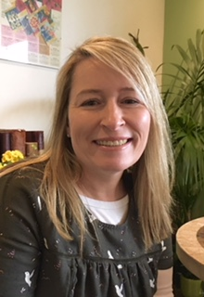

Your teaching assistant will be Mrs Sanjana (Keyworker)

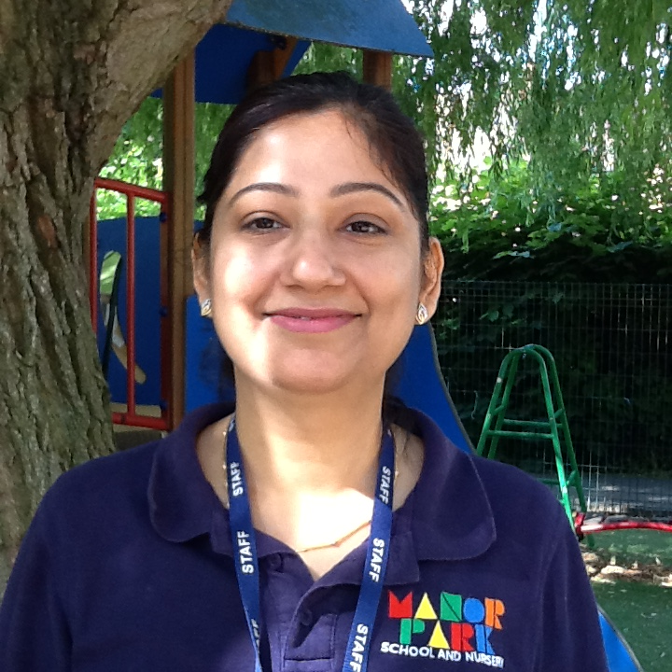

I am looking forward to:

____________________________________________

I am not sure about:

____________________________________________

Thank you for your help in completing this ‘Starting Nursery’ booklet.

We will keep it in your child’s ‘Learning Journey’ book as a record of their thoughts and achievements before they started Nursery.

We will continue to promote our Home – Nursery partnership throughout your child’s life at Manor Park Nursery.

