
Nursery Application Form

Contact Information
Head Teacher – Mr S. Cotterill
Telephone – 01625 568837
Email – admin@manorpark.cheshire.sch.uk
School Website – www.manorpark.cheshire.sch.uk
 Manorparkprimaryschoolandnursery

Our opening times are as follows:

Full Day: 8.45am-3.30pm (a packed lunch must be provided)
Morning Nursery Session: 8.45-11.45am
Lunch: 11.45am-12.30pm (a packed lunch must be provided)
Afternoon Nursery Session: 12.30-3.30pm

Please indicate below which sessions you would like your child to attend. These are subject to availability.

For more information about availability and the cost of our childcare provision, please speak to one of the Nursery staff or contact the school directly.

Session | Monday | Tuesday | Wednesday | Thursday | Friday
Morning 8.45-11.45am
Lunch 11.45am-12.30pm
Afternoon 12.30-3.30pm

Start date:____________________________________________________

Signature ____________________________________________________

Print name _________________________________ Date______________

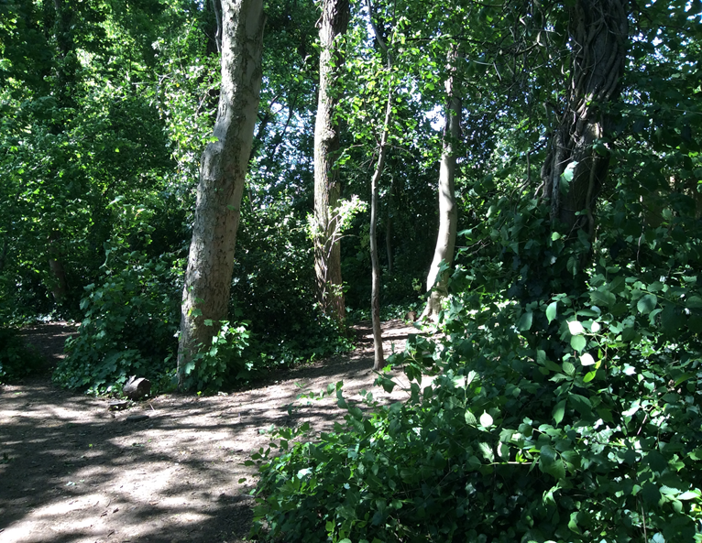

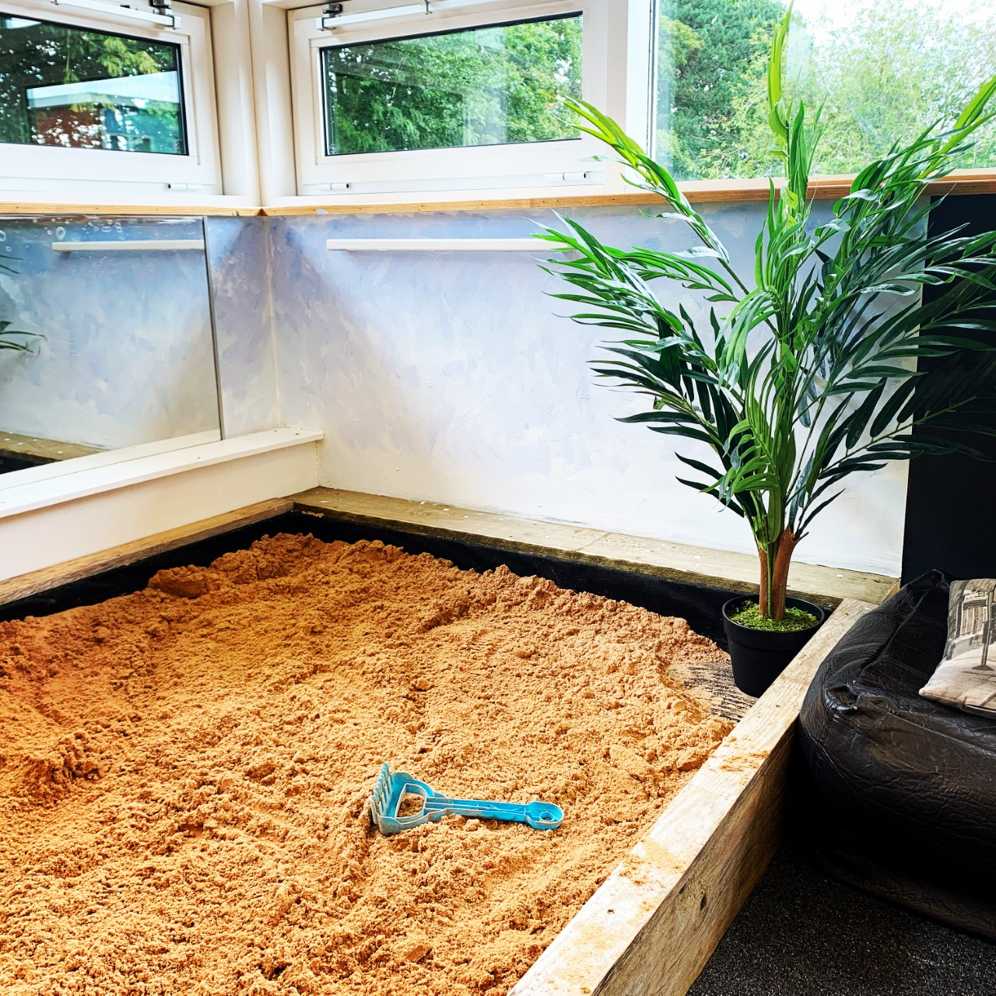
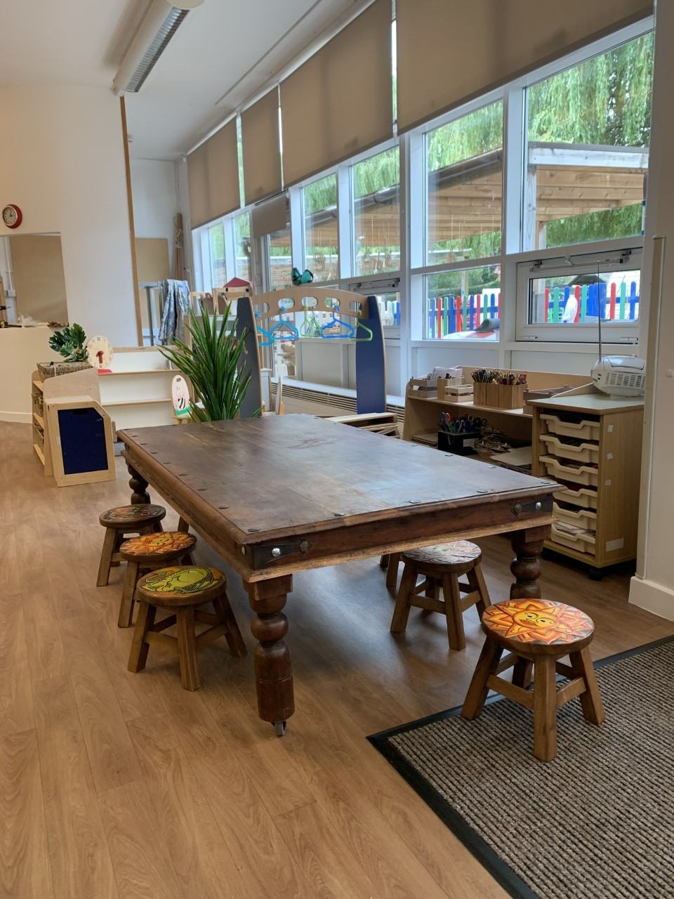

 2 Year Old Room Miss Sweeney (please tick)
 3/4 Year Old Room Mrs Hoyle (please tick)

Welcome to Manor Park School and Nursery

Promoting the values of…
Respect, Pride, Responsibility, Resilience and Reflection

Here at Manor Park our children are polite, friendly, clever, respectful, hard working, energetic, risk takers, dancers, musicians, maths wizards, star readers, star writers, scientists, problem solvers, mini journalists and most importantly…VERY HAPPY

Their journey begins in our Nursery. We look forward to your child beginning their journey with us.

2 Year Old Room - funded children can start in the 2 year old room the term after their 2nd birthday. Non-funded children can start as soon as they turn 2.

3/4 Year Old Room - children can start in the 3/4 year old room the term after their 3rd Birthday.

In order to help all children to settle into Nursery quickly, admissions are staggered throughout their first half-term with home visits, play sessions and Nursery visits already having taken place. (This is explained in more detail in the 2 Year Old and Nursery booklets).

Some 2 year olds are eligible for 15 hours (5 sessions) free childcare per week. All 3 & 4 year olds are entitled to 15 hours (5 sessions) free childcare per week. Some 3 & 4 year olds are eligible for 30 hours (10 sessions) free childcare per week.
For more information, please visit…

childcarechoices.gov.uk

Name of Child: _______________________________________________
Date of Birth: ________________________________________________

Other children in the family: (Names and ages)
____________________________________________________________
____________________________________________________________
____________________________________________________________
Name of other childcare settings attended (past or present) _____________
____________________________________________________________

If you change your address, contact number or no longer require a nursery place, please inform us as soon as possible.

Parent/Carer Name:

Address:

Phone:
Mobile:
Email:
Parent/Carer Name:

Address:

Phone:
Mobile:
Email:

